Student’s Name
Professor’s Name
Course
Date of Submission
Self-Deprecating Humour: Student Life
While the practice of including student perspectives is highly valued and considered a necessity in higher education, many processes that are designed to channel their voices are limited to institutional efforts toward gaining a competitive advantage. In other words, student magazines in colleges and universities limit sensitive issues that any given student can openly speak of. Consequently, to ensure that their concerns are heard and possibly addressed, students are increasingly inventing new ways of expressing themselves in a variety of non-institutional settings. Available evidence shows the memefied and blogged discourses on social media and other internet-based platforms represent some of the widely used avenues among students to air their marginalized stories (Ask & Abidin 836). Consequently, this essay utilizes two memes by “Student Problems (SP),” a Facebook page dedicated for self-expression among students, and blog Lauren Miller’s blog article, “High School Homework: Are American Students Overworked?” to examine how students use downright fun to express how they feel about student life stressors.
The overall theme that emerges from the two memes, Meme 1 and Meme 2 (“Netflix and No Chills” and “Me Right Now”), and the article is overwhelmed. Both reveals the ubiquitous presence and far-reaching impacts of student’s stressors, which tend to stretch far beyond their study halls, hostels, and the classroom. The student in Meme 1 is seen watching Netflix at the comfort of her couch, with the entertaining aspect of Netflix used figuratively to represent one of the leisurely pursuits of students and other society members (SP). Unfortunately for this student, the relaxing activity becomes a stressful experience when she suddenly remembers deadlines, assignments, as well as exams. On remembering class related activities, she loses her ability to rest and watch peacefully. Meme 2 depicts a man on fire, burning from toe to head, but he still manages to walk calmly (SP). This meme suggests that distressed students are forced to hide their feelings by keeping up appearances in pain. In other words, students find these negative experiences too shameful to express.
Miller’s article was first published in Teen Link, a monthly print magazine for teens. The author’s main subject is no different from the overall focus of the two memes as she argues that American students are overworked. She achieves this painting a picture of “a young girl who sits at her desk” to review homework assignments on various subjects; English, math, science, and French, all of which involve heavy workload such as reading up to “three chapters,” “doing a worksheet,” and completing 30 problems,” (Miller par. 1). According to Miller, this constitutes typical weeknights for one in five students countrywide. From the article and the memes, the primary message is that the various student’s problems are inescapable and least likely to change in the near future. By using words such as “Me Right Now,” “a typical weeknight,” and “No Chills,” the creators of these content believe that enduring the agony resulting from the insurmountable demands of student life is the only option for students (SP; Miller par. 1).
Miller and SP have utilized concepts of logos, pathos, kairos, and ethos to appeal to the target audience. Regarding ethos, Miller is a student and teen in grade seven, with SP serving as a platform for students to express themselves, making both sources credible. Equally important, these student authors and meme creators have made themselves vulnerable by speaking from first-person point of view, making the information relatable from the students’ perspectives and firsthand encounters with exams and other stressors. The concept of logos features Miller’s article when she refers to the National Education Association (NEA) guidelines that direct teachers to give no more than 10 and 20 minutes of homework for first and second graders, respectively. Pathos becomes evident when Miller wonders why educators sometimes double or triple the amount of homework. Moreover, the memes appeal to the audience emotionally by depicting a burning man and a restless student, who cannot have a peaceful leisure time. Concerning the concept of kairos, the arguments in these memes and the article are timely because parents, students, and other education stakeholders are complaining about the negative effects of too much homework for learners.
Meme 1 (Netflix & No Chills) | Meme 1 (Me Right Now)
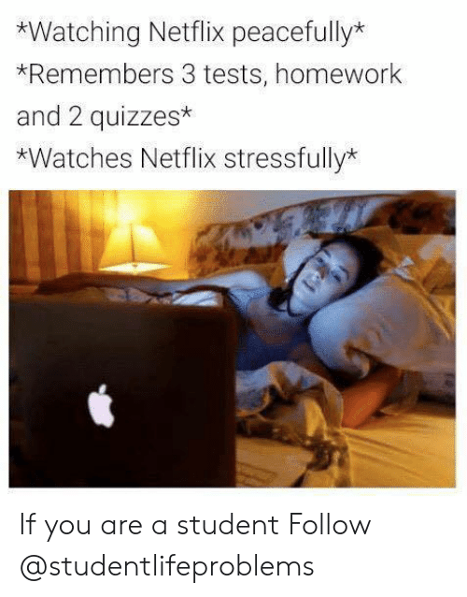 | 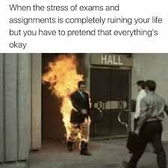

Works Cited
Ask, Kristine, & Abidin, Crystal. “My Life is a Mess: Self-Deprecating Relatability and Collective Identities in the Ramification of Student Issues.” Information, Communication, & Society, vol. 21, no. 6, 2018, pp. 834-850.
Miller, Lauren. “High School Homework: Are American Students Overworked?” Huffington Post, Jan. 2, 2012. Available at https://www.huffpost.com/entry/high-school-homework-are-_n_1071973
Student Problems (SP). “Me Right Now.” Meme, May 12, 2017. https://mobile.facebook.com/StudentProblems/videos/1240962276030503/?hc_ref=OTHER&_rdc=1&_rdr&refsrc=http%3A%2F%2Fwww.google.com%2F
Student Problems (SP). “Netflix and No Chills.” Meme, Mar. 1, 2019. https://www.facebook.com/StudentProblems/videos/1234331963360201/?comment_id=630550620471915&comment_tracking=%7B%22tn%22%3A%22R0%22%7D

